HARDWARE COOLING IN COMPUTERS

EVALUATING THE EFFICACY OF A PIEZOELECTRIC FAN FOR THERMAL DISSIPATION OF A CPU IN A DESKTOP COMPUTER

BY

MATTHEW CLAYTON DUNAWAY

A THESIS (AN ADVANCED DESIGN PROJECT) SUBMITTED TO THE FACULTY OF SAINT MARTIN’S UNIVERSITY IN PARTIAL FULLFILLMENT OF THE REQUIREMENTS FOR THE DEGREE OF MASTER’S IN COMPUTER SCIENCE

SAINT MARTIN’S UNIVERSITY

8/15/2022

CSC 598(3) CERTIFICATE OF APPROVAL

HARDWARE COOLING IN COMPUTERS

TESTING THE EFFICACY OF A PIEZOELECTRIC FAN FOR THERMAL DISSIPATION OF A CPU/GPU IN A DESKTOP COMPUTER

BY

MATTHEW CLAYTON DUNAWAY

Date of Acceptance

---

Special Committee directing the master’s degree for Candidate

Mr. Matthew Clayton Dunaway

 _____________________________

Dr. Xuguang Chen, Associate Professor

Project Advisor

**Abstract**

Today’s computing hardware has been standard for the past decade. The motherboard serves as the backbone for the CPU, SSD/HDD, temporary memory, video/sound cards, power connection, input/ output ports, heat sinks and fans. (Fisher, 2021) Other than the race to make components smaller and performance metrics higher, manufacturers have striven for stability. Computer component stability is defined as resistance to shock and environmental factors using semiconductor components that can switch and amplify direct and alternating current. This has been accomplished with amazing success with the advent of the solid-state drive. Integrated circuits take the place of moving magnetic disks to improve the overall portability of the hard disk computer component. (Sheldon, 2021)

Since the creation of the modern computer, engineers have battled the fragile hardware comprising this delicate machine. Recent developments in memory storage drives have supplanted a sizable portion of the commercially available disk drives with solid-state drives. Large strides have also been made in the development of a solid-state lithium battery using sulfides as a solid electrolyte instead of a gel or liquid electrolyte solution. Battery technology is being developed for safety and portability reasons in the automobile industry but can be used in many applications. Samsung, one of the companies leading the research, advises a solid-state battery will be available for market testing in 2023. ("What is a Solid-state Battery?", 2020) With a solid-state battery, computers will have a safer and more stable power supply. One of the few components in a computer that has moving parts is the rotary cooling fan. Regardless of the technological breakthroughs achieved thus far, nothing can negate the need to remove heat from a stable electromechanical computer. Currently, the rotary fan is the only practical component used for thermal dispersion in commercially available desktop and laptop computers. Rotary fans are well understood, thoroughly evaluated, and cheaply manufactured. (James, 2022) The downside is that computers are still machines with moving parts and susceptible to environmental factors and emit electromagnetic and audio noise that can impair other sensitive equipment. (Smoot, 2022)

This paper will discuss an alternative technology, the solid-state piezoelectric (PZ) fan, and how it compares to the rotary fan in efficiency of thermal dispersion in the modern desktop computer. Furthermore, this paper will discuss the results of a proof-of-concept (POC) build and recorded thermal datapoints from both rotary and PZ fans on the CPU of the POC desktop. The results from this POC will be used to discuss future research needed to make solid state (PZ) computer cooling fans commercially viable.

**Table of Contents**

Chapter 1: Piezoelectricity (PZ) Background…………………………………...….….…....6

Rotary Fans……………………….………………………….………………………….….6

Figure 1: Rotary Fan Air Flow …………………….……………………………………....7

Figure 2: Rotary Fan Motor ……………………………………….……………………….7

Figure 3: Rotary Fan Heat Sink …………………………………………………………...7

Figure 4: Rotary Fan Air Flow 2……………………………………………………………7

Piezoelectric Fans…………….………..……………………….…………………………..8

Figure 5: Piezoelectric Effect ………….……………….……………….…………………8

Figure 6: Two Piezoelectric Wafers ……………….……………………………………...8

Figure 7: : PZ Fan Vortex Formation and Velocity …………………….………………10

Figure 8: : PZ Fan Vortex Formation and Pressure ……………………………...……10

Chapter 2: Research Review…………………………………………………………………10

Chapter 3: Desktop-Mounted Piezoelectric Fan Project Description…………………….12

Chapter 4: CPUID Software…………………………………………………………….....…14

HWMONITOR PRO ……………………………………… ……….…………...………...14

Figure 9: HWMONITOR Console Example………………………...…………………...15

PowerMAX ……………………………………………………………………….………...15

Figure 10: Two CPU Dies and CPU Package……………..……………………………16

Chapter 5: Testing……………………………………………………………………………..17

Picture 1: : Test Computer Rotary Fan Setup ………….………………………….…...17

Chart 1: Rotary Fan Effect on CPU Package Temperature …………………..………18

Picture 2: Test Computer No-Fan Setup…….……………………………………….….19

Chart 2: No-Fan Effect on CPU Package Temperature……………………………….19

Picture 3: Test Computer PZ Fan Setup (front)……….……………………………..…20

Picture 4:Test Computer PZ Fan Setup (side)…….…………………………..…....…20

Chart 3: PZ Fan Effect on CPU Package Temperature...………………………….....21

Chart 4: Fan 2D Line Chart Comparison Test #1……………………………………...21

Chart 5: Rotary Fan Effect on CPU Package Temperature Test #2………………...22

Chart 6: No Fan Effect on CPU Package Temperature Test #2……………………..23

Chart 7: PZ Fan Effect on CPU Package Temperature Test #2…………………......24

Chart 8: Fan 2D Line Chart Comparison Test #2……………………………………...25

Chart 9: Average CPU Package Temperature Test #1 vs Test #2……………...…...25

Chart 10: Burn In Test…………….......................................................................…..27

Chart 11: Burn In Cooldown Time……………………………………………………….27

Chart 12: Fan Type Wind Velocity…………………………………..……………...…...28

Chapter 6: Conclusion……………….………………………………….…..………………..28

Chart 13: Fan Box Chart Comparison Test #1……………………………………....…30

Chart 14: Fan Box Chart Comparison Test #2…………………………..…………..…31

Acknowledgement………………….………………………………………..………………..32

References………………….………………………………………………..………………..33

**Chapter 1: Computer Cooling Background**

**Rotary Fans**

The world is ever moving towards greater efficiency. Nowhere is this more evident than the push for efficiency in technology. Scientists are constantly trying innovative ideas and rework old ideas to find a better way to perform a task. This is the case for improvements in computer cooling technology. The tech industry has transitioned from machines that have limited runtime due to overheating, to heat sinks dissipating heat into ambient air, to fans pushing air through heat sink fins. The rotary fan cooling a heat sink through convection (Figure 1, Figure 3) is the most popular setup for personal and commercial computers because it is the most understood and most affordable. (James, 2022) Rotary fans function via an electrically induced magnet attached to a rotor that is alternately charged to push and pull against a permanent magnet around it (Figure 2). The two main types of rotary fans used for moving air are axial and radial fans. Axial fans move air parallel to the rotor shaft (Figure 4) and move a large volume of air while creating a low air pressure. This low air pressure distributes a high air volume in a widely defined area. Radial fans have a centrifugal motion and move air from the center to radial areas producing low air volume and high air pressure capability. These radial fan characteristics produce a steady air flow to a narrowly defined area. The other key characteristic that differentiates the two fan types is energy consumption. The axial fan uses much less energy than the radial fan and is the main type of rotary fan used in computers. ("The Difference Between an Axial and Radial Fan", 2019) This energy efficiency is a key determinant in the component choice for computer cooling.

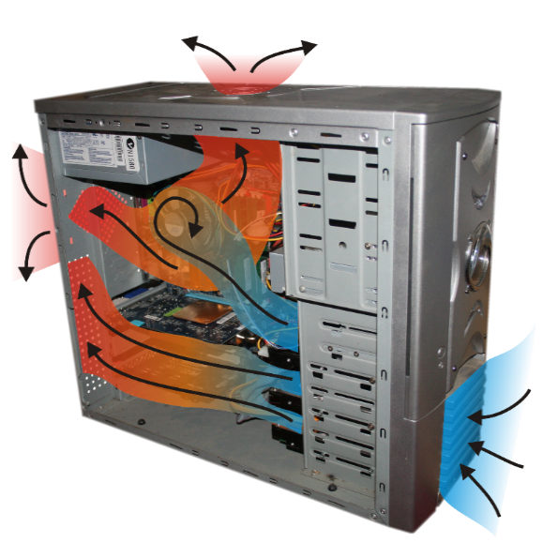

Figure 1: Rotary Fan Air Flow (Fosnez, 2022) Figure 2: Rotary Fan Motor (SolidWorks Tutorial #267, 2017)

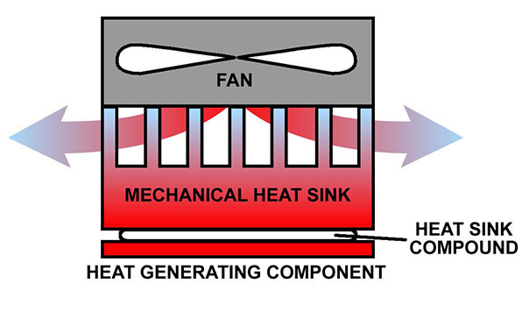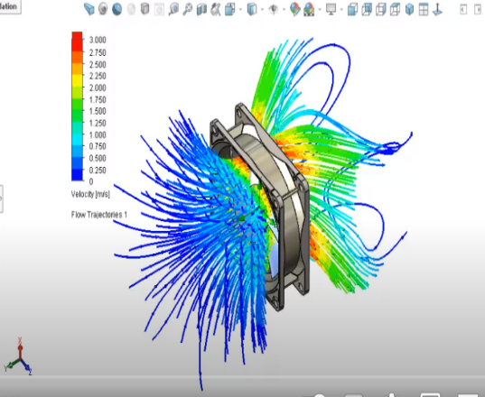

Figure 3: Rotary Fan Heat Sink (Techspray, 2022) Figure 4: Rotary Fan Air Flow 2 (SolidWorks FL Tutorial #282, 2017)

**Piezoelectric (PZ) Fans**

Piezoelectricity (PZ) is an effect that certain solids can create when exposed to external physical stress. This effect can be observed in proteins, ceramics, and crystal. When mechanical stress is applied to the chemical lattice of the solid structure, positive and negative charges are induced by the movement of atoms in or out of that structure (Figure 5). The opposite effect can be observed when the lattice is subjected to electrical stimulation. ("Piezoelectricity - Wikipedia", 2022) The generation of motion using a miniscule charge is the process behind the piezoelectric fan. Using a crystal’s chemical lattice, an electric current can drive the bending of a flat surface. If two piezoelectric wafers are placed on either side of a flexible paddle (Figure 6), an oscillating motion can be created. These are the fundamentals behind the lead zirconate titanate (PZT-5A4E) piezoceramic fan.

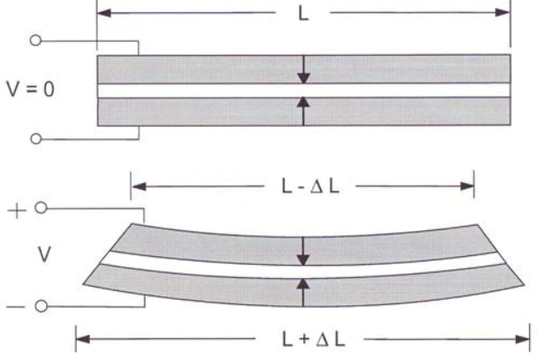

Figure 5: Piezoelectric Effect (Piezoelectricity- Wikipedia, 2022)  Figure 6: Two Piezoelectric Wafers (Carter & Kinsley, n.d.)

The flow of air generated by this piezoceramic fan is not laminar due to the vortices of air induced by the paddle oscillation (Figure 7 and Figure 8). Vortices of air do not pass-through standard heat sink fins efficiently and do not move the heated air away from the component being cooled. Nonetheless, numerous academic and industrial trials have proven the cooling efficacy of PZ fans. Currently, their application is suited for cooling small electronic components and not for mass air movement needed in system cooling. This is due to the popularity of single beam fan implementation and lack of thoroughly tested multibeam piezoelectric fan configurations. Recent advances in numeric modeling software have rapidly increased the multibeam designs that are being evaluated in academic and industrial settings due to PZ fan’s 50% reduction in energy consumption of cooling systems. (Hales & Jiang, 2018) PZ fans also emit no residual electromagnetic radiation, require no lubrication, and disperse no ferromagnetic particles into the environment. More specifically, the PZ fan seen at *piezo.com* is hermetically sealed to eliminate performance interference from elevated temperatures, dust, high humidity, corrosive chemicals, and extreme pressures. ("Sealed Piezo Fan User Guide - Piezo Support", 2021) PZ fans already have a wide array of applications, from aerospace thermal dispersion in the International Space Station to liquid/air pump cooling inside closed systems in the geothermal, chemical, and petroleum industries. The next logical application of the PZ fan’s benefits should be to increasingly complex and sensitive computer architecture.

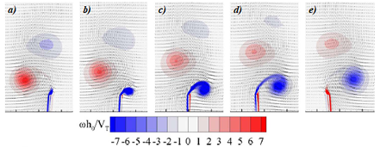

Figure 7: PZ Fan Vortex Formation and Velocity (Choi, Cierpka & Kim, 2012)

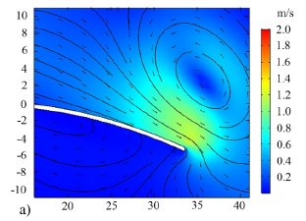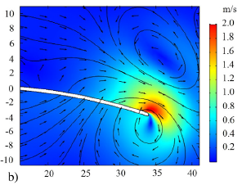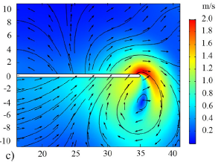

Figure 8: PZ Fan Vortex Formation and Pressure (Maaspuro, 2016)

**Chapter 2: Research Review**

In preparing for a proof-of-concept design for using a piezoelectric fan to cool a desktop computer, I first reviewed as much published literature as I could find relative to a piezoelectric (PZ) fan utilized for thermal dissipation. In defining the scope of published literature for a PZ fan, I started with US patent records. The PZ fan was patented in 1985 by the Murata Manufacturing Company after the creation of many other piezoelectric tools such as a tuning fork and a tuning fork vibrator. ("Google Patents", 2022) The novelty of the invention came from the application of a natural property of certain solids to emit electrons when pressure is applied to them. This can be seen in click lighters when the pressure release at the end of the trigger causes an electric arc at the lighter hood. The team at Murata reversed the effect to produce flexing of a quartz crystal lattice when an electric current is applied. ("Google Patents", 2022) With the dates defined as 1985 to present, I searched Google Scholar for the subject scope of *"piezoelectric fan" desktop*, *"piezoelectric fan" desktop computer,* and "*piezoelectric fan" piezo.com*. There were no scholarly publications solely dedicated to the thermal performance of a piezoelectric fan in a desktop (computer) or thermal performance of a *piezo.com* piezoelectric fan in a desktop (computer). ("Google Scholar", 2022) There are, however, hundreds of articles detailing various configurations, applications, fluid dynamics, and thermal performance of piezoelectric fans. The review of research and application of technology performed in 2016 by Mika Maaspuro at Aalto University, Finland, was the most applicable scholarly work to my research proposal subject area. (Maaspuro, 2016) From her research review, the cooling effect of a radial fan’s laminar flow is optimal for thermal dissipation. This renders the flow of the oscillating cantilever fan sub-optimal without the help of flow directing housings. Her experiment did not use flow housing and relied on a 50mm x 7mm cantilevered beam of a PZ fan to cool an isolated heatsink 1 mm away from the fan tip. The fan resonance was 14 HZ with a tip displacement of 22mm. The oscillation was driven by 60 VAC and used 7mW - 13mW of power. This produced a 30% reduction in thermal resistance (temperature drop of the heat sink) compared to natural convection. The project proposed here uses the computer case as a flow housing and a 79.5mm x 20.8mm cantilevered PZ beam with a tip displacement of 28mm to cool an integrated heatsink 1 mm from the fan tip. 120 VAC will drive the oscillation and will use 1W of power. Her research article and the fan user guide available at piezo.com are the resources I am relying on for my proof-of-concept build specifications. (Sealed Piezo Fan User Guide - Piezo Support, 2021) After reviewing current research and literature on the applications of piezoelectric (PZ) fans, there is no data on the PZ fan’s thermal efficiency in a working desktop computer. There is, however, a plethora of studies about the history and applications of this type of fan as an auxiliary cooling mechanism. This paper does not seek to resolve all levels of PZ fan architectural and system optimization as applied to a desktop computer. It simply proposes to explore the preliminary assessment of PZ fan feasibility in a current model desktop computer. It does not address cooling in laptop computers, however that would be a prime area for further research. Feasibility will be evaluated using thermal data (temperature) of the CPU of a working desktop computer using both rotary and PZ fans. The PZ fan will be deemed feasible if it can cool the CPU enough to prevent heat-related damage and/or thermal shutdown of the computer.

**Chapter 3: Desktop-Mounted Piezoelectric (PZ) Fan Project Description**

In describing the testing phase, it is important to understand the basics of the system we are performing tests on. The desktop computer is made of multiple components working together to perform common arithmetic tasks rapidly. These components require electricity, more specifically electrons, applied to function logic gates. The electrons travelling through the circuits create heat through resistance. This heat is moved away from the CPU with a heat sink. The purpose of the heat sink is to expose this heat to a large surface area of cool air for the purpose of heat exchange/heat removal. The fan maintains a temperature difference between the heat sink and air by moving warmed air away from the heat sink and allowing heat exchange to happen faster than it would otherwise without the fan. The speed and size of fan blades determines how much and how fast that warmed air can be moved away from the heat sink and replaced with cool air. Feasibility of PZ fan application is derived from the question of whether the PZ fan can move as much air around the heat sink as the standard rotary fan. The answer could be thought of as a simple volume equation, but this can only be applied to like systems, such as rotary fan to rotary fan or oscillating fan to oscillating fan. The flow dynamics of a rotating blade are markedly different from an oscillating PZ blade in terms of how air is moved. The comparison is like assessing the miles per gallon of an internal combustion engine and an electric motor. The goal is the same, but the metric of performance is different. Therefore, performance measurements are taken and interpreted at the end of the system (the thermal dissipation effect the fan has on the CPU) rather than evaluation of the volume and speed of air moved. Air flow speed exiting the heat sink will be measured by an anemometer to judge whether there is any correlation between flow speed and thermal dissipation efficiency of the two fan types evaluated (rotary and PZ). For this experiment, a Hewlitt Packard ProDesk 600 G1 SFF Slim Business desktop will be used as the computer system. It has an Intel Pentium i5 4590 processor with 4 cores, 3.70 GHz processing frequency, and 84 Watts of thermal design power (power consumed). The maximum CPU temperature cooled with a rotary fan for 20 hours will be compared with the same setup cooled with a PZ fan for 20 hours as measured by open-source software, HW Monitor Pro v1.09. The measurements are taken with software so the computer case can be closed, as a desktop computer would be in everyday use. The PZ fan will be considered feasible if the PZ fan can keep the max CPU temperature below the shutdown temperature specified in the CPU manufacturer specifications.I am not determining feasibility of the PZ fan at the same CPU temperature or thermal performance as the rotary fan. The rotary fan has the benefit of decades of engineering optimization and customization applied to computer system cooling. Further design improvement and testing of the PZ fan may be warranted to match rotary fan performance if the initial feasibility of the concept proves to be successful.

# **Chapter 4: CPUID Software Tools**

## **HWMONITOR PRO**

HWMonitor Pro is built on the CPUID System Monitoring Development Kit (Figure 9). This kit allows any Windows application with administrator privileges to monitor and report sensor information on every supported system device. (Grumeau, 2018) Another advantage is the high refresh rate on sensor data and real-time sensor information. HW Monitor Pro is used in this test for the purposes of accessing the Intel Core i5 processor package temperature in real-time and recording that temperature on a log every 0.5 seconds for 8,000 data points. The complete log is equivalent to approximately 75 minutes. The log of 8,000 points will be repeated for 20 hours to provide as much temperature data as possible for the fan configuration being evaluated. The data will then be compiled into a csv file, cleaned so that dataset volume matches, and then median/maximum running temperatures of each cooling solution evaluated. The findings are then presented in the results and discussion portion of the report.

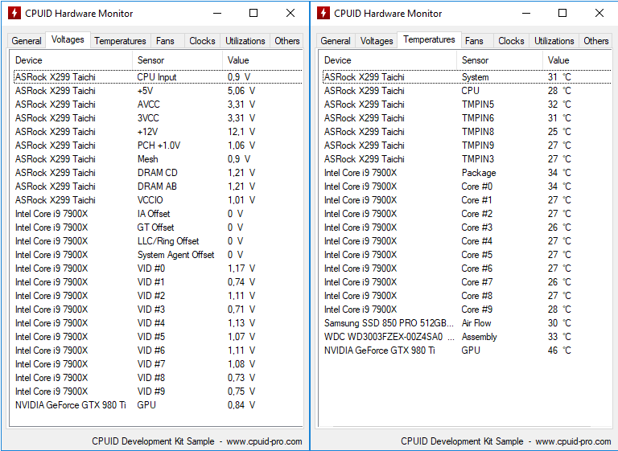

Figure 9: HW Monitor Console Example (Grumeau, 2018)

## **PowerMAX**

PowerMAX software is a CPU and GPU burn-in test that maximizes the power dissipation and temperature of both components. This allows the user to check the overall system stability by stressing the CPU/GPU thermally and assessing whether the power supply and cooling system are performing their jobs correctly. There is no score to grade a system on. The PowerMAX software is a pass or fail burn-in test where component shutdown from exceeding internal temperature maximums for a given time is a fail and the ability to dissipate heat for the system to continue operating over a given time is a pass. The maximum temperature a system is designed to dissipate is called the Thermal Design Power (TDP). When a system exceeds TDP, the operating system will signal a temperature fuse to shut the system down. (Grumeau, 2022) Most modern processors operate between the temperatures of 40-70°C. In the Intel Pentium i5 processor, the average temperature range is 50-62 °C. The maximum temperature the Intel Pentium i5 processor can manage at the semiconductor level is 100°C. The CPU cores that handle a single process is also called a die. There are multiple dies in a CPU package. The HW Monitor Pro software can measure each die or give a package temperature. Since there are multiple dies in a package and determining the max component temperature is the goal of this research project, this test will measure the max CPU package temperature in °C.

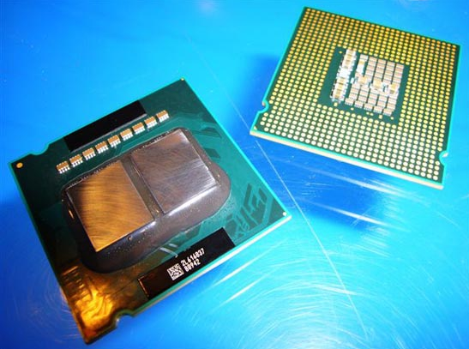

2 CPU Dies

1 CPU Package

Figure 10: Two CPU Dies (*left*) and One CPU Package (*right*) (Shimpi, 2006)

# **Chapter 5: Testing**

The first test was the 20-hour rotary fan and was started on 10/6/2022 at 17:54 CST. Data was collected until 10/7/2022 at 19:54 CST. The ambient temperature was kept between 21.66-24.44°C, and humidity between 50-55%. After cleaning the datapoints, there were 147,499 temperature points collected for the rotary fan test. The average temperature of the CPU cooled with the factory-installed rotary fan was 30.78°C with a minimum temperature of 27°C and a maximum temperature of 48°C.

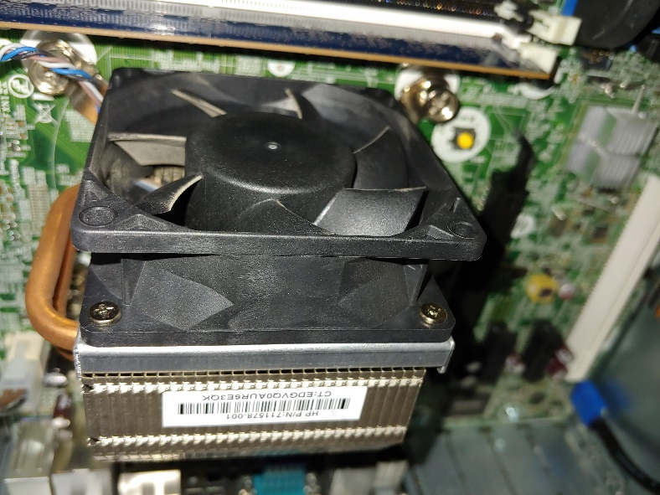

Picture 1: Test Computer Rotary Fan Setup

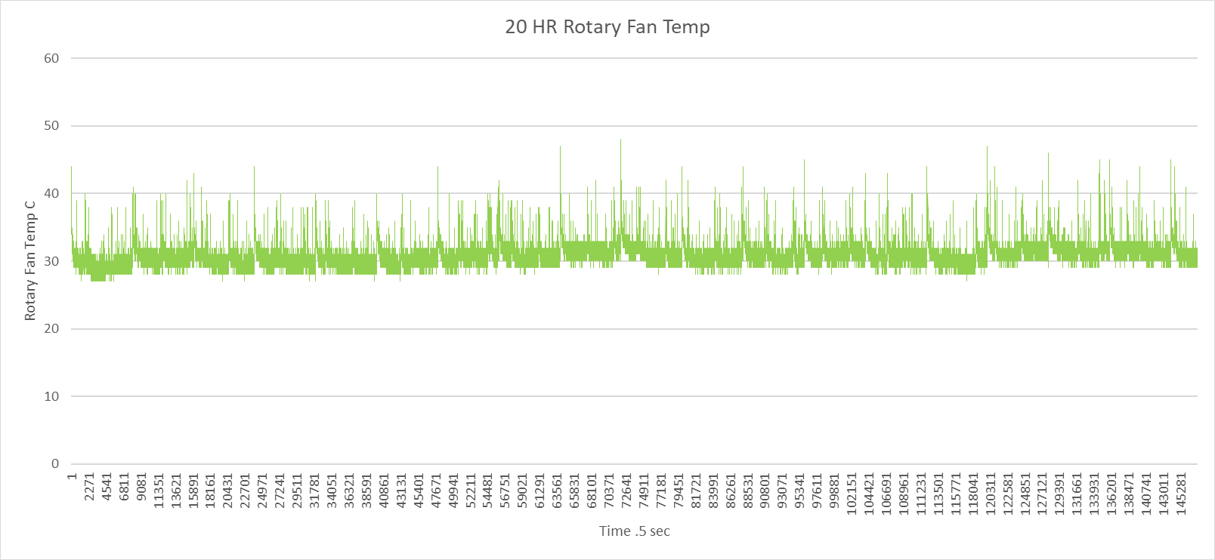

Chart 1: Rotary Fan Effect on CPU Package Temperature

I then unplugged the rotary fan from the motherboard and attempted to run a 20-hour no-fan temperature test on 10/7/2022 at 21:08 CST. The ambient temperature was kept between 21.66-24.44°C, and humidity between 50-55%. After cleaning the datapoints, there were 71,618 temperature points collected for the no-fan test over 10 hours. The temperature stayed within the average temperature tolerance of the i5 processor until the 10th hour, when the temperature spiked to 87°C. Since the critical temperature range for an Intel Pentium i5 is from 90-100°C, I immediately plugged the rotary fan back in to prevent CPU damage and ceased evaluating the computer system without a fan. The average temperature was 37.38°C, the minimum temperature was 28°C and the maximum temperature was 87°C.

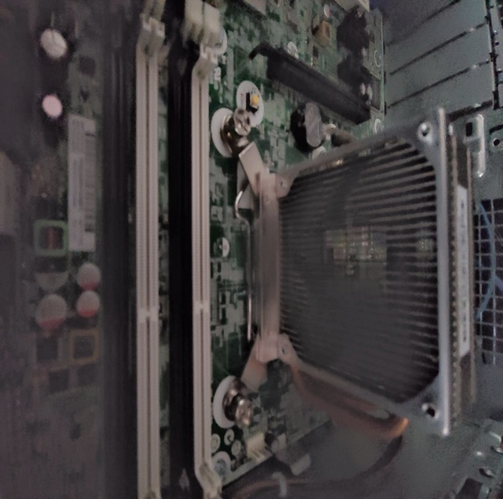

Picture 2: Test Computer No- Fan Setup

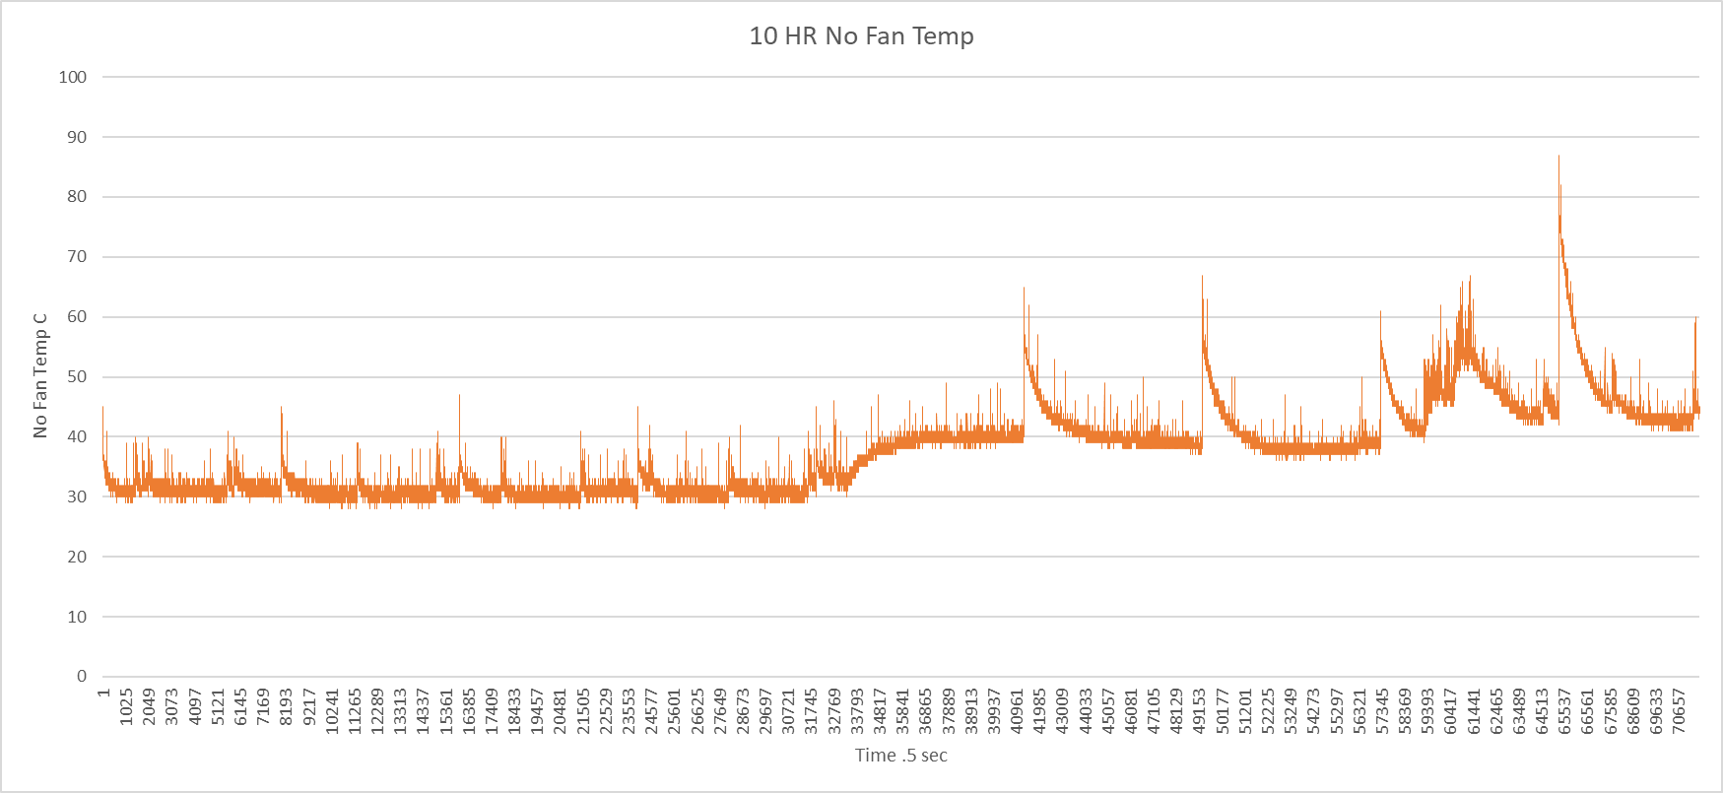

Chart 2: No-Fan Effect on CPU Package Temperature

Lastly, I mounted the *piezo.com* piezoelectric (PZ) fan kit (Model 12) on a 13.5” aluminum L-bar 1 mm away from the heat sink fins, actuating vertically to fin relation and plugged in the 120VAC power adapter. I started the test on 10/10/2022 at 17:43 CST and ran the temperature log until 10/11/2022 at 1803 CST. The ambient temperature was kept between 21.66-24.44°C, and humidity between 50-55%. After cleaning the datapoints, there were 147,499 temperature points collected for the PZ fan test. The average temperature of the CPU cooled with the PZ fan was 35.20°C with a minimum temperature of 29°C and a maximum temperature of 58°C.

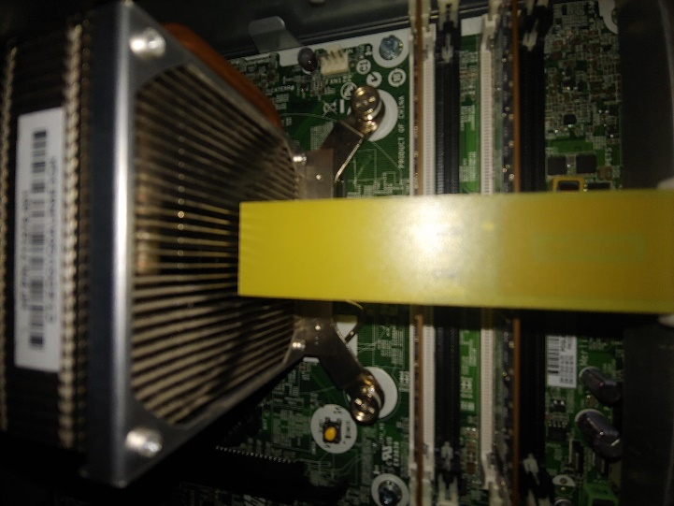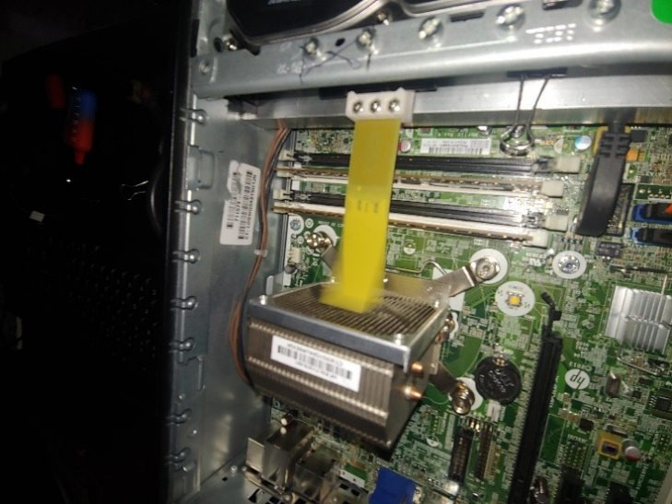

Picture 3: Test Computer PZ Fan Setup (front) Picture 4: Test Computer PZ Fan Setup (side)

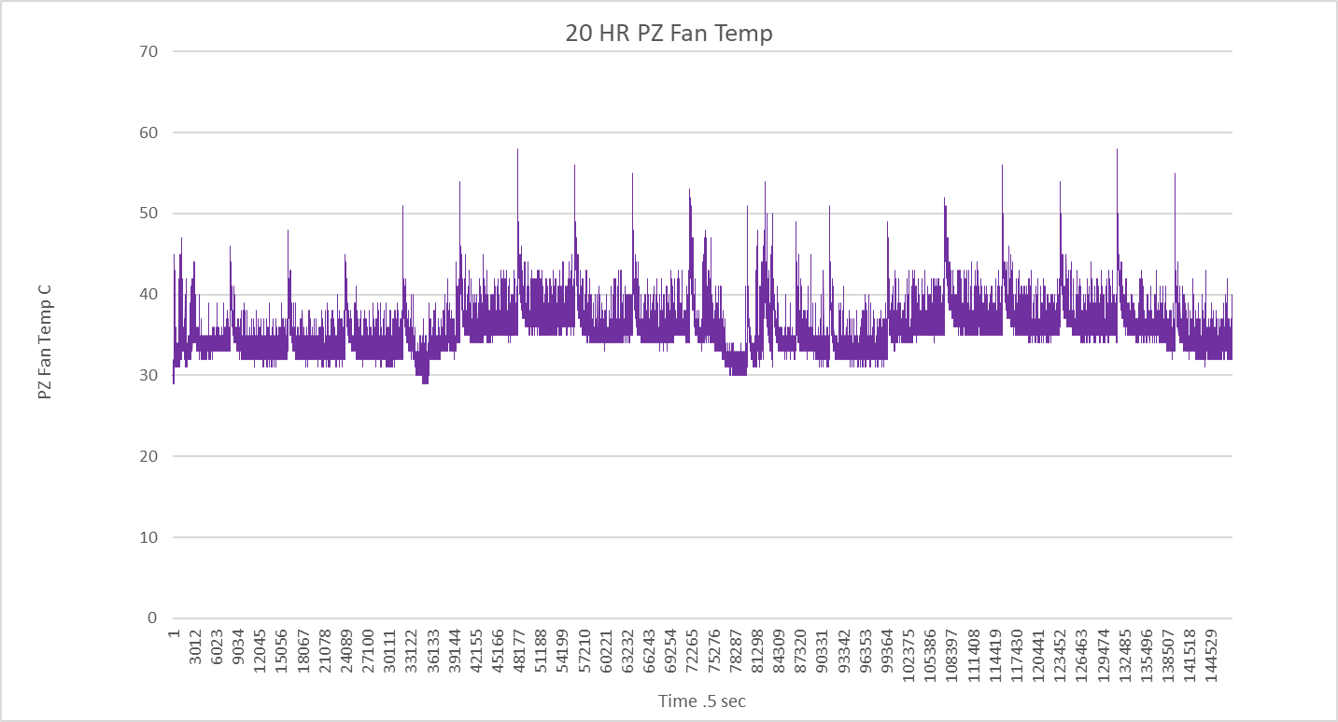

Chart 3: PZ Fan Effect on CPU Package Temperature

The side-by side comparison of each fan setup (Chart 10) illustrates the no fan shutdown at 10 hours. It also illustrates the similarity of cpu temperature maintained by both the rotary fan and PZ fan for 20 hours of datapoints.

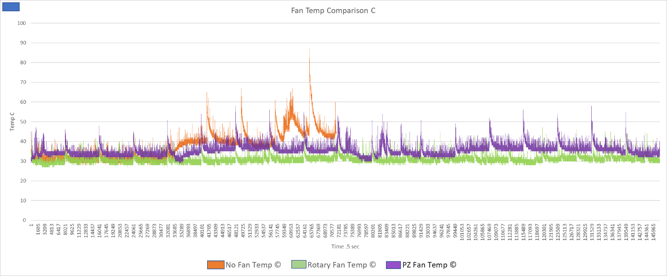

Chart 4: Fan 2D Line Chart Comparison Test #1

To ensure scientific reproducibility of the fan comparison data, a second 20-hour test was performed on each fan configuration from 11/5/22 to 11/8/22. The ambient temperature was kept between 21.66-24.44°C, and humidity between 50-55%. After cleaning the datapoints, there were 147,499 temperature points collected for the 20-hour rotary fan test, which was approximately 20 hours. The average temperature of the CPU cooled with the rotary fan in test #2 was 33.53°C, the minimum temperature was 31°C and maximum temperature was 51°C.

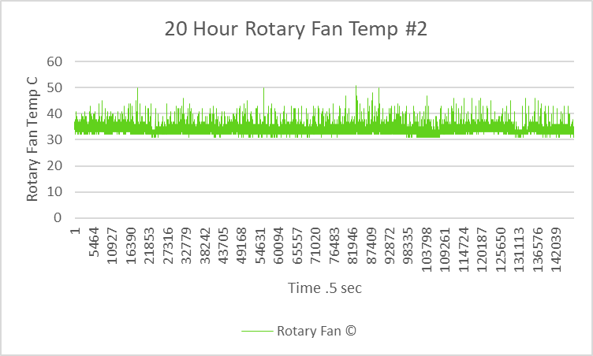

Chart 5: Rotary Fan Effect on CPU Package Temperature Test #2

To get as many data points as possible, I allowed the no fan configuration to run the entire 20 hours, despite the CPU temperature rising to the critical range (>70°C) multiple times. This data set is important because it exemplifies the temperatures expected if the PZ fan has no effect on the natural convection of a CPU heat sink. The ambient temperature was kept between 21.66-24.44°C, and humidity between 50-55%. After cleaning the datapoints, there were 147,499 temperature points collected for the 20-hour no fan test, which was approximately 20 hours. The average temperature of the CPU cooled with no fan in test #2 was 52.88°C, minimum temperature was 32°C and maximum temperature was 100°C.

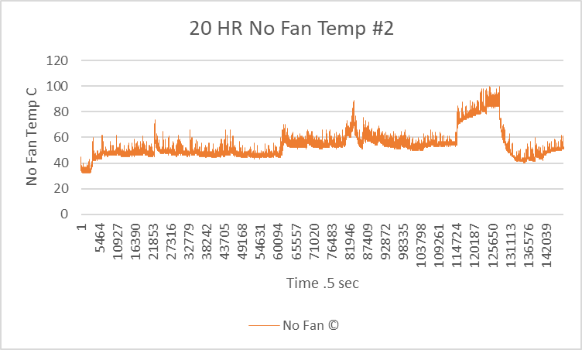

Chart 6: No Fan Effect on CPU Package Temperature Test #2

The average temperature of the CPU cooled with the PZ fan in test #2 was 37.76°C, minimum temperature was 31°C and maximum temperature was 69°C.

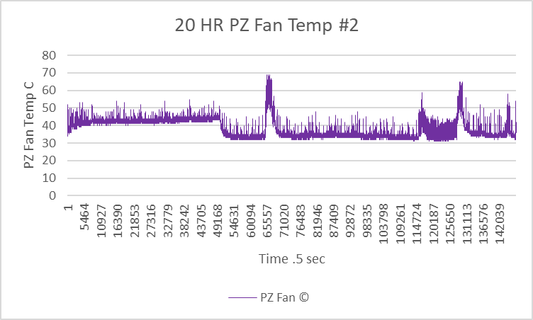

Chart 7: PZ Fan Effect on CPU Package Temperature Test #2

The second 20-hour test results of the average CPU temperature for the rotary and PZ fan were within 3°C of the first 20-hour test results. Considering the ambient temperature range in the test environment varied by +-2.22°C, the CPU average temperatures substantiate reproducibility of the data. The 20-hour test with no fan raised the average CPU temperature from 37.38°C to 52.88°C, which is what would have been expected had the test not been stopped halfway through the first run. The side-by side comparison of test #2 results is seen below in Chart 8.

Chart 8: Fan 2D Line Chart Comparison Test #2

|  |  |  |  |
| --- | --- | --- | --- |
| **Fan Type** | **Test #1 CPU Temp AVG ©** | **Test #2 CPU Temp AVG ©** | **Test #2 Thermal Reduction Efficiency %** |
| **Rotary Fan** | 30.78 | 33.53 | 36.59 |
| **Piezoelectric Fan** | 35.20 | 37.76 | 28.59 |
| **No Fan** | 37.38 (*10hrs*) | 52.88 | -- |

Chart 9: Average CPU Package Temperature Test #1 vs Test #2

To gather data on how each fan configuration would manage maximum CPU utilization, a 1 minute, 100% utilization test was performed twice using PowerMAX software. According to the software description, it stresses a computer in a way that reveals weaknesses of certain components. (Grumeau, 2022) The CPU test selected used SSE (streaming single-instruction-multiple-data extensions) programming to execute parallel processing on every core of the CPU simultaneously. This test ensures that 100% of the CPU capacity is utilized the entire test period to rapidly maximize the power dissipation and temperature. The goal here is for the fan to dissipate heat rapidly enough to prevent CPU damage. It is aptly called the “burn in” test because it will burn the component evaluated if there is a deficiency in the cooling system. It does not produce a thermal performance score and cannot be considered a benchmark. (Grumeau, 2022) It is simply high stakes pass-or-fail thermal testing. All fan configuration tests began at a baseline temperature of less than or equal to 40°C. These were 39°C for no fan, 39°C for the rotary fan, and 40°C for the PZ fan. It took 2.0 seconds from recording the temperature log to press the start button on the PowerMAX CPU burn in test. At 62 seconds, all temperatures peaked at 96°C for no fan, 83°C for the rotary fan, and 91°C for the PZ fan. All fan configurations prevented CPU damage that takes place at 100°C. When the CPU had cooled to 45°C the test was started again. It took 368 seconds for no fan, 18.5 seconds for the rotary fan, and 63.5 seconds for the PZ fan to cool to 45°C. Fan temperatures peaked the second time with 100°C for no fan, 86°C for the rotary fan, and 96°C for the PZ fan. The no fan configuration failed to keep the temperature below the 100°C shutoff temperature while the other two configurations did. It took 466.5 seconds for no fan, 30 seconds for the rotary fan, and 98 seconds for the PZ fan to cool the CPU back to 45°C. This test was performed to subjectively determine if the PZ fan could withstand the rigors of cooling an overclocked computer for a set time. It succeeded in keeping the CPU from shutting down for 1 minute. The cooldown time for each setup here is also meant to be subjective but provides data for further objective testing to be based upon.

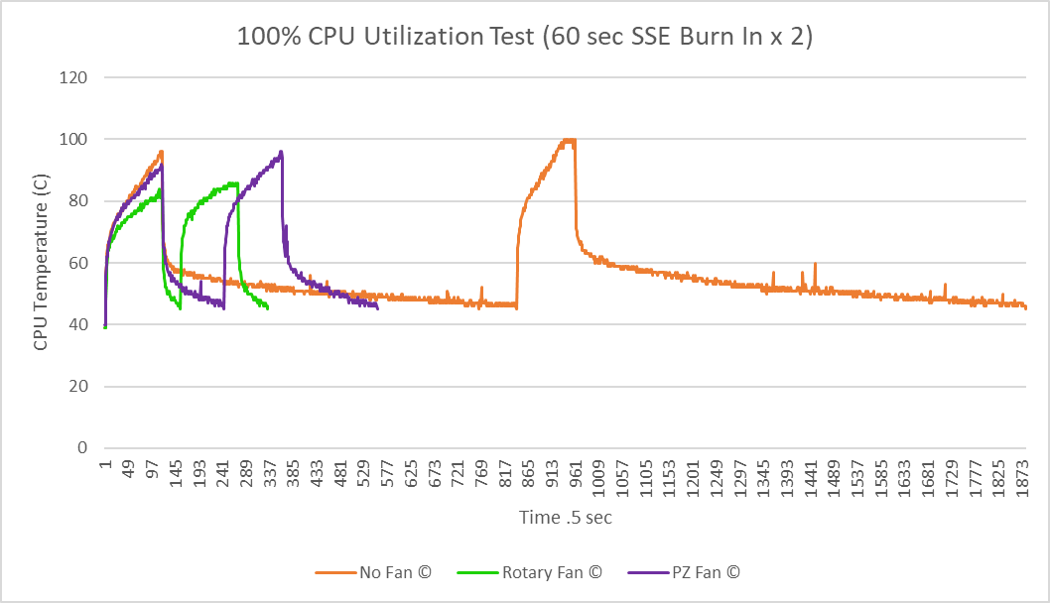

Chart 10: Burn In Test

|  |  |  |
| --- | --- | --- |
| **Fan Type** | **Cooldown Time to 45°C Test #1 (.5 sec)** | **Cooldown Time to 45°C Test #2 (.5 sec)** |
| **Rotary Fan** | 18.5 | 30.0 |
| **Piezoelectric Fan** | 63.5 | 98.0 |
| **No Fan** | 368.5 | 466.5 |

Chart 11: Burn In Cooldown Time

As well as performing tests on the ability of fans to cool the CPU of a desktop computer system, wind speed readings were also taken of each fan configuration. The rotary fan and the PZ fan were removed from the computer mount and powered outside the desktop case. An anemometer was held 1mm away from each fan tip. The rotary fan wind speed measured 6.54mph and the PZ fan wind speed was 2.65mph. The velocity of wind exiting the heat sink was also measured while each fan was powered. The rotary fan wind speed is controlled by a temperature sensor in the operating system that increases rpms of the fan blade as the computer component temperature increases. The rotary fan post heat sink measurements were 6.0mph, 22.5mph, and 44.0mph. The PZ fan post heat sink wind speed measured 0.5mph. The attempt to measure any wind velocity outside the desktop case and after the heat sink strictly due to natural convection in ambient air (*no fan configuration*) revealed no measurable effect. These measurements were used to calculate if there was a linear correlation between wind speed and cooling efficiency. The rotary fan efficiency of 36.59% had a wind speed of 6.54mph. The PZ fan had a wind speed of 2.56mph. If there was a linear correlation, the PZ fan should have shown a 14.32% efficiency. Instead, it had a thermal efficiency of 28.59%. It is therefore determined that wind speed did not linearly correlate to thermal dissipation efficiency.

|  |  |  |  |
| --- | --- | --- | --- |
| **Fan Type** | **Pre Heat Sink Wind Speed (mph)** | **Post Heat Sink Wind Speed (mph)** | **Ambient Temperature Change ©** |
| **Rotary Fan** | 6.54 | 6.0, 22.5, 44.0 | 0.0 |
| **Piezoelectric Fan** | 2.56 | 0.5 | -0.8 |
| **No Fan** | 0.0 | 0.0 | 0.0 |

Chart 12: Fan Type Wind Velocity

**Chapter 6: Conclusion**

In the full 20 hour run of test #2, the rotary fan reduced thermal resistance by 36.59% and the PZ fan reduced thermal resistance by 28.59%. This matches the thermal efficacy seen in the research review. Flow speed did not correlate to a linear increase in thermal dissipation efficiency. PZ fan efficiency (28.59%) was far greater than expected PZ thermal efficiency (14.32%) if a correlation to flow speed existed. One hypothesis is that the vortex formation and reduction of forced air temperature compensates for the decrease in wind velocity seen in the PZ fan versus the rotary fan. The results for the rotary fan and the PZ fan were remarkably similar regarding average (baseline) temperature. They stayed within ~4°C of each other’s average running temperature for 20-hour runs with the desktop case closed. Neither had any temperature spikes that were in the critical thermal range for the Intel Pentium i5 processor. In fact, the rotary fan and the piezoelectric fan kept the CPU average temperature well below the optimal running temperature of 40-70°C. While the test run with no-fan did have an average temperature of 37.38°C in the first test and 52.88°C in the second, this number alone does not do a satisfactory job determining whether a hardware cooling setup is effective. The first no-fan test run was stopped at 10 hours and not allowed to continue running in the critical range. This accounts for the 20°C increase seen from test #1 to test #2. Both no-fan test averages are within optimum temperature ranges for the Pentium I5 processor but do not take into consideration temperature increases above 70 degrees for short durations. Repeated or prolonged critical temperatures damage the CPU and are not feasible for a cooling solution. The spike in max CPU temperature into and above the critical temperature range for the I5 processor with simple internet browsing (Chart 4, Chart 8) makes it an unsuitable cooling solution. The ambient air does not have the ability to respond to low utilization of the CPU and, thus, overheating occurs in the no-fan setup.

The box chart seen below is used to compare the large quantity of temperature readings gathered from the three setups. The top and bottom whiskers are the top and bottom 25% of the temperature readings with the box representing the 50% of readings in the middle. The dots above and below the whiskers are the extreme outlier temperature readings. The outliers tend to follow peak CPU utilization. This chart gives a very good illustration of the similarities and differences in thermal dissipation performance of the fan tests. The difference in the three tests are 1) the no-fan setup had numerous outliers that are in the critical/shut off temperature range for the Intel Pentium i5, whereas 2) the rotary and PZ fan results have none. This thermal control illustrated in the rotary and PZ fan tests is critical to prevent CPU shutdown and irreversible damage. The median for each test is symbolized by the line inside the box. The three fan setups had a similar median temperature in the first 20-hour run because of the shortened no-fan test run time. The median average is markedly higher in the second test with a full 20-hour run of the no-fan configuration.

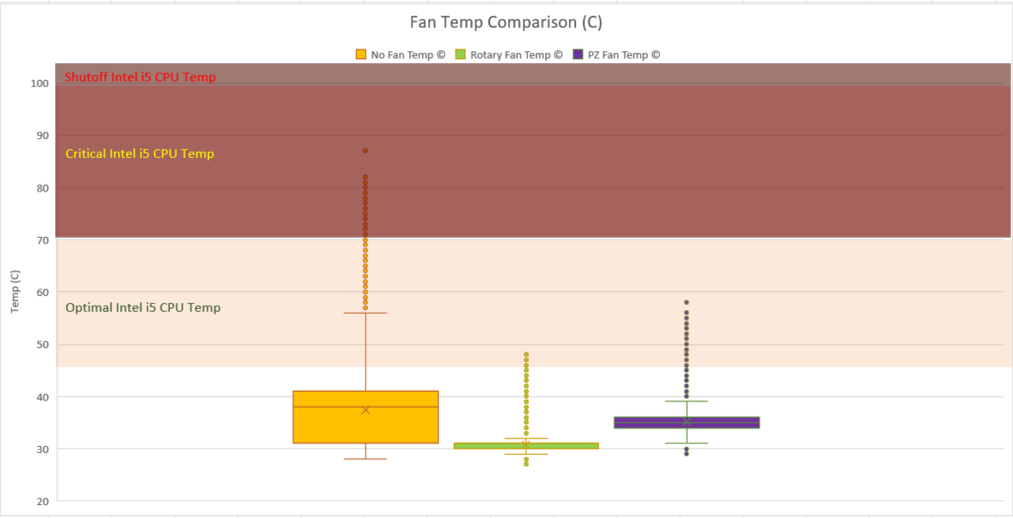

Chart 13: Fan Box Chart Comparison Test #1

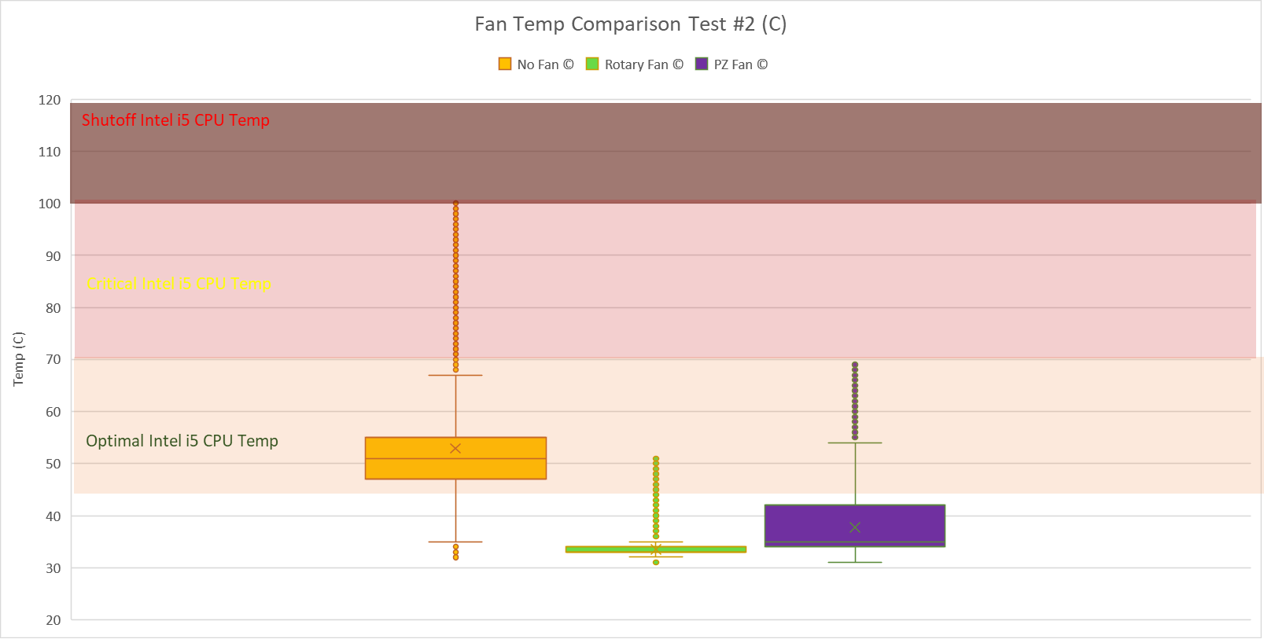

Chart 14: Fan Box Chart Comparison Test #2

Given the fact there has been no design optimization of the PZ fan, and the highest expectation for the PZ fan test was to keep the CPU cooled below critical temperatures, the piezoelectric fan was an effective cooling technique for this test. While test results show the PZ fan takes three times as long to cool the CPU back to baseline, this cooling time could be improved with multiple PZ fans, rounded heat sink fins to maintain vortex formation, or wind directionalization. The PZ fan maintained an average CPU temperature within 4°C of the rotary fan and kept the CPU temperature below shutoff value in both tests that were run on it as a standalone cooling technique. With the rotary fan consuming 6 watts of power and the PZ fan only using 1 Watt, the PZ fan was 5 times as energy efficient with similar thermal performance.

The desktop computer used in this experiment has two rotary fans installed. One cools the CPU, and one cools the power supply. The CPU produces the most heat in most computer systems so the assumption is that the PZ fan can also cool the power supply as effectively as the CPU. With the known power savings of 5 watts per fan, the application of this cooling using two fans could save 10 watts of power per computer. The average desktop consumes 60-250 Watts of power. (Northwestern University, 2018) PZ fans could make desktops 4-16% more energy efficient immediately. Server warehouses, government agencies and military garrisons all rely on stationary computing as seen in this desktop computing scenario. 10 watts over 1000 computers for 365 days is 3,650,000 watts or 3.65 Megawatts. That is enough to power 600 American residences for one hour or a single residence for 4.38 months. (EIA, 2021) Given a future that places increasing emphasis on energy conservation as one component in the effort to contain global warming, every solution needs to be explored. Specific areas believed appropriate for further computer science research after this project include the following:

* Further testing of PZ fans in a variety of desktop computers of different makes, models, and CPU capacity.
* Further testing of approaches to enhance PZ efficiency/functionality (materials used, airflow, power supply (both AC and DC) and other components of PZ design and construction.
* Testing of PZ application to servers, laptop computers, and tablets in various configurations.

**Acknowledgement**

I would like to thank my parents Donnie and Becky Dunaway for purchasing the PZ fan. Thank you to Dr. Alexander Mezai, Buck Frymier, and Jonathan Hall for proofing this research paper. Thank you to Peter Truax for helping me walk through the testing methodology and technical aspects of this research paper. I would also like to express my deep appreciation to Dr. Xuguang Chen my project advisor who encouraged me to take on this difficult project when it did not look or sound feasible. He has been a fantastic advisor whose wisdom and guidance have been invaluable to me in completing this experiment and fulfilling the requirements of the Master’s Degree in Computer Science.

**References**

1. Fisher, T. (2021). Do You Actually Know What Your PC's Motherboard Does? Retrieved 24 August 2022, from <https://www.lifewire.com/motherboards-system-boards-and-mainboards-2618154>.
2. Sheldon, R. (2021). What is solid-state technology and how is it used?. Retrieved 24 August 2022, from <https://www.techtarget.com/whatis/definition/solid-state>
3. Wang, Y. (2017). Power Efficiency of Piezoelectric Fan Cooling. Retrieved 27 August 2022, from <https://escholarship.org/uc/item/7t55h4hz>
4. Solid-state electronics - Wikipedia. (2022). Retrieved 27 August 2022, from <https://en.wikipedia.org/wiki/Solid-state_electronics>
5. Kazmeyer, M. (2022). How Does a CPU Cooling Fan Work?. Retrieved 19 September 2022, from <https://smallbusiness.chron.com/cpu-cooling-fan-work-61608.html>
6. James, D. (2022). Best CPU coolers in 2022. Retrieved 19 September 2022, from <https://www.pcgamer.com/best-cpu-coolers/>
7. Fosnez. (2022). File: Computer case cooling air flow.png - Wikimedia Commons. Retrieved 19 September 2022, from <https://commons.wikimedia.org/w/index.php?curid=6112079>
8. How Heat Sink Compound Keeps Electronics Cool | Techspray. (2022). Retrieved 19 September 2022, from <https://www.techspray.com/how-heat-sink-compound-keeps-electronics-cool>
9. Sealed Piezo Fan User Guide - Piezo Support. (2021). Retrieved 20 September 2022, from <https://support.piezo.com/article/139-sealed-piezo-fan-user-guide#overview>
10. Smoot, R. (2022). Comparing Axial Fans and Centrifugal Fans. Retrieved 20 September 2022, from <https://www.digikey.com/en/articles/comparing-axial-fans-and-centrifugal-fans>
11. Rose, B. (2022). Understanding Airflow Fundamentals for Proper Dc Fan Selection | CUI Devices. Retrieved 20 September 2022, from <https://www.cuidevices.com/blog/understanding-airflow-fundamentals-for-proper-dc-fan-selection>
12. Google Patents. (2022). Retrieved 20 September 2022, from <https://patents.google.com/patent/US4780062A/en>
13. Application Notes - Piezo Support. (2020). Retrieved 20 September 2022, from <https://support.piezo.com/article/116-application-notes>
14. SolidWorks Tutorial #267: DC motor. (2017). Retrieved 26 September 2022, from <https://www.youtube.com/watch?v=oboHOnBIXrY>
15. SolidWorks FL Tutorial #282: PC Fan with flow simulation analysis. (2017). Retrieved 26 September 2022, from <https://www.youtube.com/watch?v=Vr9A2oVy570>
16. The Difference Between an Axial and Radial Fan. (2019). Retrieved 27 September 2022, from <https://paulsfans.com/blog/difference-axial-radial-fan/>
17. Burmann, P., Raman, A., & Garimella, S. (2002). Dynamics and topology optimization of piezoelectric fans. IEEE Transactions on Components and Packaging Technologies, 25(4), 592-600. Doi: 10.1109/tcapt.2003.809111
18. Piezoelectricity - Wikipedia. (2022). Retrieved 27 September 2022, from <https://en.wikipedia.org/wiki/Piezoelectricity>
19. Midé Technology. (2015). Packaged Piezoelectric Fan Qualification and Reliability Testing [eBook]. Retrieved from chrome-extension://efaidnbmnnnibpcajpcglclefindmkaj/https://s3.amazonaws.com/helpscout.net/docs/assets/5a60b15b0428635d7f439dde/attachments/6058bee7207e3b1188e1eaf7/20150415_Piezo_Fan_Reliablity_Public_Release.pdf
20. Google Scholar. (2022). Retrieved 5 October 2022, from <https://scholar.google.com/scholar?hl=en&as_sdt=0,10&q=%22piezoelectric+fan%22+piezo.com>
21. Google Scholar. (2022). Retrieved 5 October 2022, from <https://scholar.google.com/scholar?hl=en&as_sdt=0%2C10&q=%22piezoelectric+fan%22+desktop&btnG=>
22. Maaspuro, M. (2016). Piezoelectric oscillating cantilever fan for thermal management of electronics and LEDs — A review. Microelectronics Reliability, 63, 342-353. Doi: 10.1016/j.microrel.2016.06.008
23. Hales, A., & Jiang, X. (2018). A review of piezoelectric fans for low energy cooling of power electronics. Applied Energy, 215, 321-337. Doi: 10.1016/j.apenergy.2018.02.014
24. Choi, M., Cierpka, C., & Kim, Y. (2012). Vortex formation by a vibrating cantilever. Journal Of Fluids and Structures, 31, 67-78. Doi: 10.1016/j.jfluidstructs.2012.03.004
25. Kumawat, K. (2019) Optimal CPU & GPU TEMPERATURE [PC & LAPTOPS] - tech centurion, Optimal CPU & GPU TEMPERATURE [PC & LAPTOPS]. tech centurion. <https://www.techcenturion.com/optimal-temperature-of-cpu-and-gpu>
26. Grumeau, R. (2018) Cpuid developers’ corner, CPUID DEVELOPERS CORNER. CPUID. Available at: <https://www.cpuid-pro.com/products-system-monitoring-kit.php>
27. Grumeau, R. (2022) POWERMAX: Software, PowerMAX. CPUID. [https://www.cpuid.com/softwares/PowerMAX.html](https://www.cpuid.com/softwares/powermax.html)
28. Shimpi, A.L. (2006) *Intel's core 2 extreme QX6700: The multi-core era begins*, *RSS*. AnandTech. <https://www.anandtech.com/show/2112>
29. EIA (2021) Frequently asked questions (FAQs) - U.S. energy information administration (EIA), Frequently Asked Questions (FAQs) - U.S. Energy Information Administration (EIA). EIA. <https://www.eia.gov/tools/faqs/faq.php?id=97&amp;t=>3
30. Northwestern University (2018) Information technology, Power Management Statistics: Information Technology - Northwestern University. Available at: <https://www.it.northwestern.edu/hardware/eco/stats.html>